**Making intraoral cannulas (IOCs)**

* 1. IOCs are a multipart tube that connects the taste delivery system to the rat’s mouth.
  2. The process of making IOCs is the following:
     1. Prepare the hot plate and set it to 210 degrees Celsius.
     2. Grab the polyethylene (PE) tubing (IOC tubing: (#802500) 0.045” X 0.062” X 0.0085”) and PE washer tubing (Washer tubing: (#804000) 0.070” X 0.110” X 0.020”). Note: According to AM-Systems the tubing will start to deform at 103 degrees Celsius.
     3. A person's hands measuring a tape

        Description automatically generatedCut the IOC tubing to between 2.5 and 2.75 cm in length.

Should be roughly this long.

* + 1. A person holding a red circuit board

       Description automatically generatedMelt the end of the IOC tubing, holding it close over the hot plate, then press on the table into a flattened circle, ensuring the tube itself is not clogged. You can use an 18/20g needle to poke through during or immediately after removing from the hot plate to ensure it cleared.
    2. Melt the end of the IOC washer tubing close over the hot plate, then press on the table or 16g needle on the hot plate until it forms a flattened circle with larger diameter than the IOC tubing melted end.
    3. Close-up of a person holding a piece of metal

       Description automatically generatedUse the razor to carefully cut a smooth washer from the melted end of the IOC washer tubing. (Some replacements for the washer can be hole-punched Teflon or ligature dental bands).
    4. A person's hands holding a needle

       Description automatically generatedA person holding a nail

       Description automatically generatedFit the washer over the IOC tubing. This can be facilitated by using a blunt 20-gauge needle passing the washer onto the needle and then using the needle to slide on the washer onto the IOC.
    5. Additionally, a little bit of heat from the soldering iron can be used to “fuse” the washer onto the IOC flared end.
  1. Surgical Preparation
     1. To prepare the needle and IOC for surgical insertion put a 20-gauge needle through the flared end of the IOC tubing.

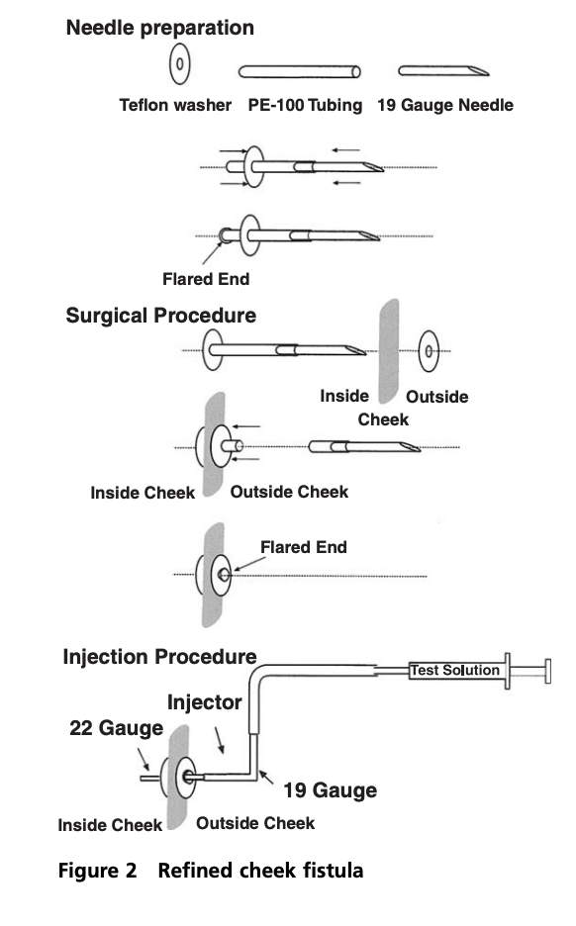

**Washer PE-100 Tubing 20 Gauge Needle**

* + 1. The other end of this is a silicone tube of 1 inch attached to a colder non-valved coupler body 1/16th inch via attaching the silicone tube to thin forceps and putting the point of the forceps into the hole on the barb-side of the coupler and sliding the silicon over onto the barb. This is then secured with VetBond.

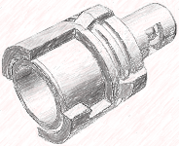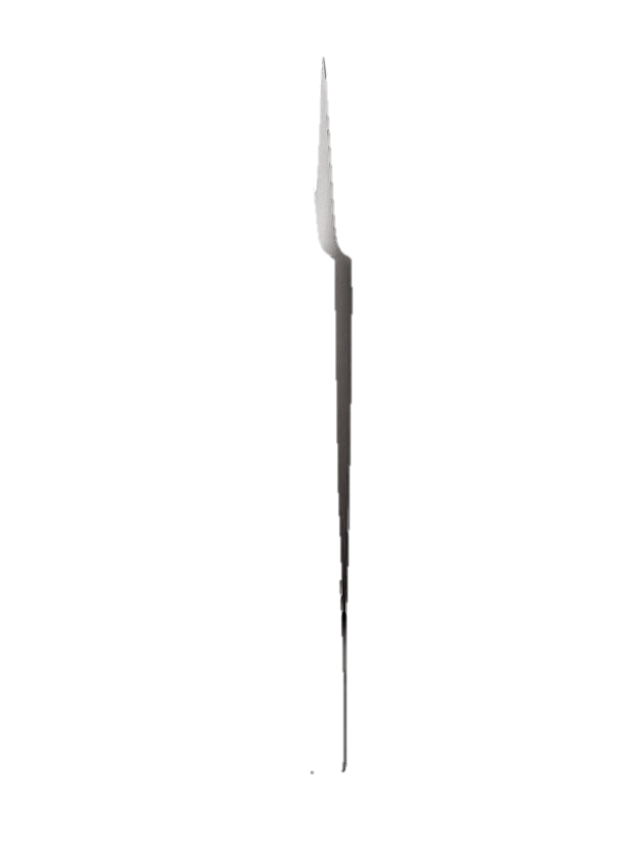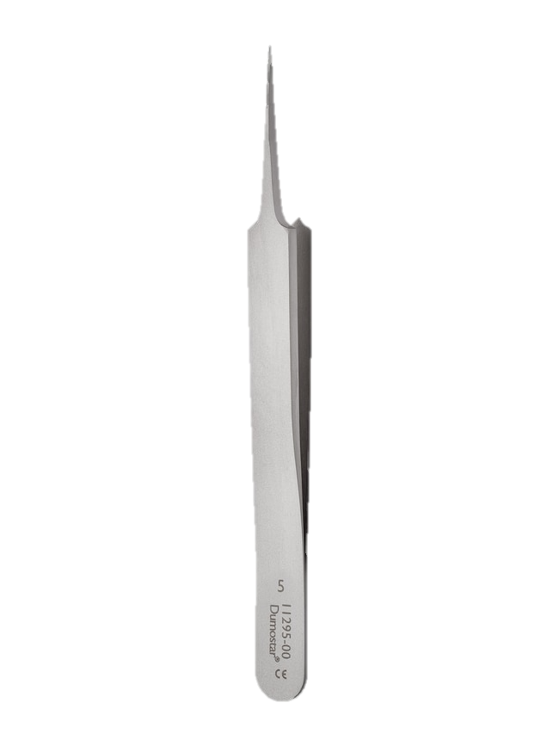

**Forceps Silicone Tube IOC Coupler**

**VetBond goes here!**

* + 1. The insertion should be right next to the second molar M2 between the teeth and the cheek.

Washer

Washer

IOC opening

IOC opening

* + 1. The inserting of the needle should follow the edge of the skull, underneath the masseter muscle, through the zygomatic arch, and up to the incision on the top of the head where the pocket hole was made.

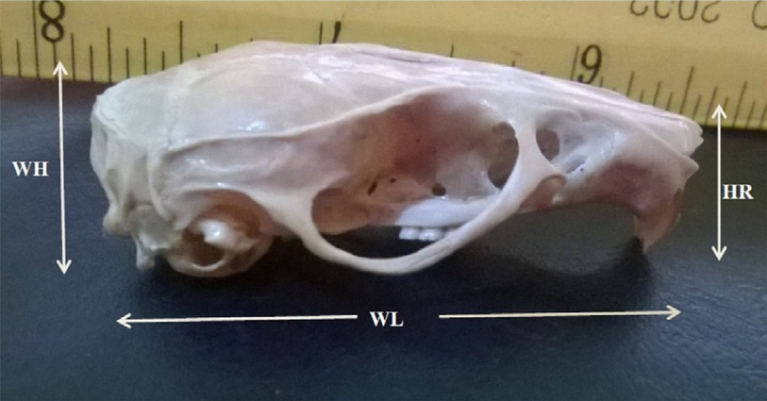

* + 1. Making and plugging up the IOC Pocket hole

**Making IOC Pocket Cleaning Open Pocket Cover Pocket with Tissue**

1.3.5 Cap for plugging up the IOC coupler and IOC itself once implanted. Use the Male Colder coupler cap attached using epoxy to PE tubing for IOC cleaning to plug up the IOC and keep it clean in-between uses.

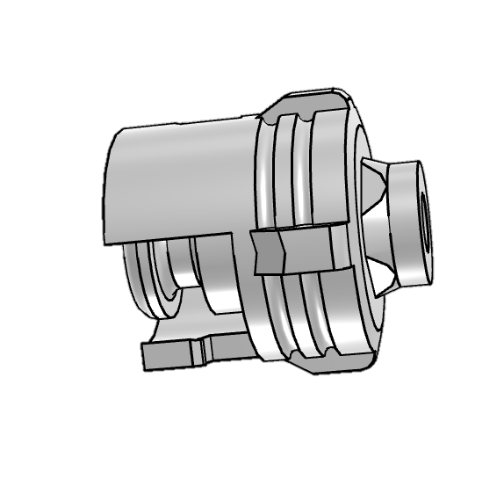

* 1. Previous Studies on Alternatives
     1. Other related work has proposed intra-cheek cannulas, intraoral cannulas the follow the path in front of the eye up to the head, and some that come out around the scapulae of the rat.
     2. A diagram of a dog's face

        Description automatically generatedExamples below:

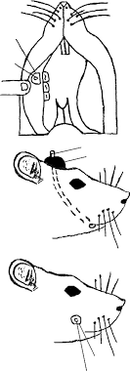

Some work recommends using chlorhexidine a cationic surfactant with broad-spectrum antimicrobial activity to disinfect the IOC during and after surgery. This is considered the “gold standard” in oral antiseptics however it has an acute effect on sodium taste perception but not on quinine although the solution has a bitter taste.

* + 1. Cutting washer to fit flush with the teeth.

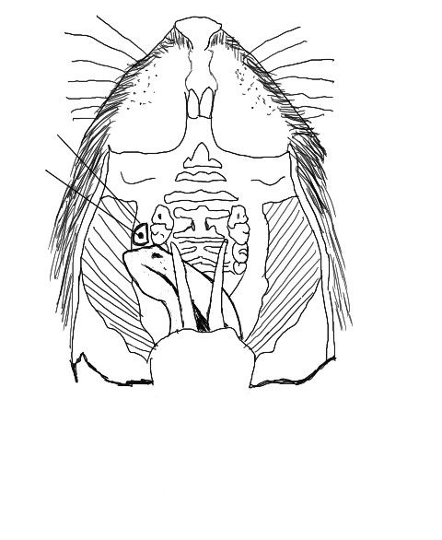

* 1. APPENDIX: Examples of IOC placements
     1. A close up of a rodent's mouth

        Description automatically generatedHere are some photographs of IOC placements in previous rats.

**Ordering Notes for IOC**

|  |  |  |
| --- | --- | --- |
| Colder coupler Male Plug | <https://www.cpcworldwide.com/General-Purpose/Products/Non-Valved/SMC/ID/SMMP> |  |
| Colder coupler female end (1/16th) | <https://www.cpcworldwide.com/General-Purpose/Products/Non-Valved/SMC/ID/SMF01> |  |
| Colder coupler male end (1/16th) | <https://www.cpcworldwide.com/General-Purpose/Products/Non-Valved/SMC/ID/SMM0112> |  |
| Polyethylene tubing | <https://www.a-msystems.com/p-225-polyethylene-tubing.aspx> |  |
| IOC Cleaning Tubing | <https://componentsupplycompany.com/product-pages/ptfe-tubing-sw.php> |  |
|  |  |  |
|  |  |  |
|  |  |  |